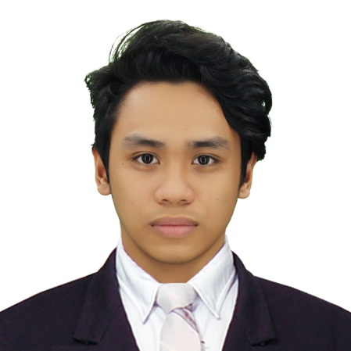

**OBJECTIVE:** To be able to improve, enhance and share my knowledge and skills in communicating, working and dealing with other people.

**PERSONAL INFORMATION**

Date of birth: July 27, 1998

Provincial address: Visayas, Leyte

Nationality: Filipino

Civil status: Single

Religion: Catholic

Height: 5’5”

Weight: 55kg

**PERSONAL SKILLS:**

* Good verbal communication
* Independent and self-sufficient in handling tasks
* Collaborative and able to work in teams or groups

**JOMARI I. HERNANDEZ**

Blk.4 Lot 25 SM Square Executive Homes subdivision. Lamesa street,

Barangay ugong, Valenzuela City.

Contact no.: (+63) 927 290 5766

[jomhernandez2714@gmail.com](mailto:jomhernandez2714@gmail.com)

**EDUCATION:**

2014-2018 **S.T.I. College** **Recto**, **Manila**

2010-2014 **Juliever Academy /**

**Raja Soliman Science and Technology High School**

2003-2010 **San Miguel Heights Elementary School**

**TECHNICAL SKILLS**

* Website Graphic design
* Database design, management and implementation
* Computer and Network troubleshooting
* Proficient in using of (Windows 7, 8, & 10 /Linux Ubuntu )
* Microsoft Office

**Operating Systems:** Windows, Linux

**Programming:** VB.NET, Jscript

**Applications:** Microsoft Office, Visual Studio, Photoshop

**Database Systems:** MySQL

**TRAININGS ATTENDED**

**On-The-Job Training Orientation Magnus Job Fair**

January 12,2018 March 6,2018

Bureau of Customs STI College Recto

**ORGANIZATIONS**

**IT Society**

Member

2014-2018